**Process of wetting properties adjustable polymeric sponges using flexible, stretchable and transparent crosslinked-polyacrylate**

1. Introduction

The porous materials composed with polymeric 3D skeleton and diverse pores hold the great public attentions and various studies have been conducted due to its incalculable applications for various fields such as environmental crisis, water purification and flexible electronics. For instance, Bilah et al. developed an elastic and stretchable porous material for adaptation of soft robotics using polyurethane diacrylate. Likewise, Zhang et al. studied strain/pressure sensor and electromagnetic shielding fields by exploring highly stretchable electronic conductive sponge employing polyurethane. Furthermore, Mo et al. investigated a highly elastic sponge for oil/water separation by applying PDMS and graphene oxide. High elasticity and outstanding stretchability are necessary to porous materials for reusability and diverse applications, however, less of studies are conducted satisfying all of these conditions due to the limitations of the material. Therefore, it is highly important to study about polymeric porous materials with high elasticity, stretchability and controlled wettability.

In order to form pores in porous materials, methods such as foaming by gas injection or phase separation using immiscible solvents can be applied, in particular, template technique using salt or sugar is the most commonly used, cost-effective and eco-friendly method. In the past decades, adopting salt/sugar template technique, various studies employed famous elastic polymer, PDMS for wettability-controlled polymeric porous materials owing to its advantages such as flexibility, elasticity and ease of fabrication, and in these studies, surface of PDMS porous material was treated with plasma deposition or silanization to control the wettability. For instance, Yan et al. employed CF4 plasma treatment to obtain the decreased surface energy of PDMS substrate. Also, Lee et al. explored about silanization of PDMS sponge using fluorosilane for hydrophobic surface. Furthermore, Lim et al. utilized oxygen plasma treatment to make PDMS sponge hydrophilic for utilizing in solar-based evaporation desalination technology. However, these special treatments are vulnerable to surface exfoliation by friction to sandpaper because only the surface properties were changed but properties of own material were not adjusted. In this regard, a new polymeric porous material is needed that maintains the changed surface energy stably even when friction is applied and has exceeding elasticity and stretchability.

Herein, we report a crosslinked polyacrylate based elastic porous materials that the surface tension was freely controlled with high stability even under the harsh corrosion. The key to our study is to control the wettability of own material constructing sponge by introducing other types of acrylic monomer. In result, our monolithic surface-controlled sponge can maintain its surface tension at friction triggered tough corrosion (ex, preserve surface tension under @@ hours of friction with sandpaper) and without additional step, wettability (from && mN/m to @@ mN/m) was efficiently adjusted. Furthermore, the presence of oxygen atoms in polyacrylate increased the intermolecular bonding and the elasticity also enhanced as the entanglement of the chain remained stable due to the strong interaction between molecules. Therefore, our monolithic porous materials can be stretched up to @@% and it is more stretchable than PDMS sponge about XX%.

또 다른 전개 (논의 사항)  
1) 젖음 특성을 조절하는 것의 중요성, 그리고 이와 관련된 소재들  
2) 하나의 소재를 활용하여 젖음성을 조절한 소재들은 별로 없었다. 또는 소재의 library를 활용한 분야가 많이 없었음  
3) 쉽고 소재의 제작 과정부터 젖음 특성을 조절할 수 있는 소재는 없을까?  
4) 우리는 아크릴레이트 소재를 활용했다.  
5) 또한 이를 스펀지 형태로 가공하여 그들의 활용성을 높였다.  
6) 마지막에는 프로토타입의 어플리케이션 두개도 보여줬다.

**Result and Discussion**

적은 양의 PEGDMA가 가해졌을 때 낮은 gel content와 높은 swelling rate를 보였습니다. 이는 낮은 가교제 함량으로 인해 가교밀도가 낮기 때문입니다. Gel content와 swelling rate는 PEGDMA의 함량이 증가함에 따라 각각 증가하거나 감소하는 결과를 보였습니다. 특히 PEGDMA 7% 함량에서 수렴하는 결과를 보였습니다. 달라진 가교 밀도는 기계적 물성에도 영향을 주게 됩니다. PEGDMA의 함량이 증가함에 따라 가교 밀도가 증가하면 고분자의 사슬 사이에 형성되는 화학적, 물리적 결합이 더욱 증가하게 됩니다. 이로 인해 사슬의 움직임에 제한이 생김과 동시에 탄성력이 증가하는 결과를 얻습니다. 따라서 오른쪽의 strain-stress curve에서 볼 수 있듯이 가교제의 함량이 증가할수록 elongation at break (%)는 감소하며 tensile strength는 증가하는 것을 알 수 있습니다. 가교제의 함량에 따라 소재의 특성이 천차만별로 바뀔 수 있기 때문에, 우리의 연구에서는 팽윤 억제도가 높음과 동시에 높은 겔화도를 갖고, 중간정도의 기계적 물성을 갖는 7% PEGDMA 함량을 선정하였습니다.

Figure 1a shows chemical structure of crosslinked-poly(acrylate) and scheme shortly. For well-knit crosslinked structure, ethyl acrylate (EA) and poly(ethylene glycol) dimethacrylate (PEGDMA) were mainly used as the monomer and crosslinker, respectively. Additionally, we aimed to control the surface energy by adding acrylate-based monomers that can adjust the wettability properties of crosslinked structures. In detail, 2-hydroxyethyl acrylate (HEA) with hydroxyl group was added for obtaining higher surface tension, and 2,2,3,4,4,4-hexafluorobutyl acrylate (HFBA) which contains fluoro-alkyl group was employed for achieving lower surface tension with higher water contact angle. As shown in Figure 1b, our crosslinked-polyacrylate possesses better flexible and stretchable characteristics due to the formation of not only a physical crosslinked structure from hydrogen bonding caused by the ethylene oxide groups in the crosslinker but also the net-like chemical crosslinked structure. This structure holds the material firmly and helps it easily recover its elasticity when stretched. Mechanical properties of crosslinked-poly(acrylate) was different according to content of the PEGDMA. In addition, we aimed to control the surface energy of this flexible and stretchable material by introducing two types of acrylates (Figure 1d). To increase the surface energy, we copolymerized acrylates with hydrophilic -OH end groups, and to decrease the surface energy, we copolymerized acrylates with fluoroalkyl groups. According to the presence of additional acrylate monomers, the surface tension was controlled appropriately and we aimed to process these crosslinked-polyacrylate to porous materials. Finally, two types of applications suitable for each surface tension were devised



Figure 1. (a) Chemical structure and simple scheme of crosslinked-polyacrylate. (b) Chemical structure and (c) drawing of normal state (above) and stretched state (below). (d) Displaying of variation of wetting control.

그림 2a에서 볼 수 있듯이, 본 소재는 가장 먼저 투명한 stretchable film으로 가공되었습니다. 필름은 매우 유연하고 약간의 접착성을 보였으며 좋은 신축성을 지녔습니다. 젖음 특성이 조절된 필름 또한 동일한 방법으로 제작되었으며, 마찬가지로 유연하고 신축성이 있었습니다. 세가지 필름의 인장시험을 진행한 결과를 그림 2a에서 확인할 수 있으며, 기계적 특성에 대한 자세한 정보는 Table 1에서 확인할 수 있습니다. Pristine PEA film의 경우 최대 인장은 @@였고, 최대 stress는 ##이었으며, 영 모듈러스는 $$였습니다. 한편, 표면에너지가 증가된 P(HEA-EA) 필름의 최대 인장은 @@였고, 최대 stress는 ##이었으며, 영 모듈러스는 $$였습니다. 이는 도입된 hydroxyethyl acrylate로 인해 수소결합이 발생함으로써 분자간 인력이 증가하게 되어 rigid하게 변하여 최대 인장이 감소한 것으로 보입니다. 또한 표면에너지가 감소된 P(HFBA-EA) 필름의 경우 최대 인장은 @@였고, 최대 stress는 ##이었으며, 영 모듈러스는 $$였습니다. 도입된 불소 알킬로 인해 분자간 인력이 감소하게 되고, 이러한 이유로 최대 인장이 감소하였습니다. 그림 2b에서는 표면 에너지가 조절된 스펀지의 젖음 특성에 관한 결과를 확인할 수 있습니다. Pristine PEA 필름에 비해 P(HEA-EA) 필름은 감소된 물, DIM 접촉각을 보여주었습니다. 두 종류의 액체 모두 접착 특성이 증가하였으며, 표면에너지를 계산했을 때 && mN/m로 증가한 값을 확인할 수 있었습니다. 이와 반대로 P(HFBA-EA) 필름은 물과 DIM 모두 접촉각이 증가함을 확인했습니다. 따라서 해당 값으로 표면에너지를 계산했을 때 확연하게 감소하는 결과를 얻을 수 있었습니다. 이러한 결과를 종합했을 때, 본 연구에서 제작된 소재는 유연하고 신축성이 좋으며, 표면의 젖음 특성을 확실하게 조절할 수 있음을 확인했습니다.

As shown in Figure 2a, the material was first processed into a transparent stretchable film. The film exhibited high flexibility, excellent elasticity and slight adhesion. Similarly, wetting properties adjusted films were produced using the same method, also maintaining flexibility and elasticity, too. The strain-stress curve results for the three films can be seen in Figure 2a, and detailed information about mechanical properties are provided in Table 1. For the pristine PEA film, the maximum tensile strength was @@, maximum stress was ##, and Young's modulus was ##. In contrast, the P(HEA-EA) film with increased surface energy showed a maximum tensile strength of @@, maximum stress of ##, and Young's modulus of &&. The decrease in maximum tensile strength is attributed to increased intermolecular forces of hydrogen bonding due to the introduction of hydroxyethyl acrylate, leading to a more rigid structure. Additionally, the P(HFBA-EA) film with decreased surface energy exhibited a maximum tensile strength of @@, maximum stress of ##, and Young's modulus of $$. The introduction of fluoroalkyl groups reduced intermolecular forces due to the strong C-F bonds, resulting in a decrease in maximum tensile strength. Figure 2b presents the wetting properties of the sponge with adjusted surface energy. Compared to the pristine PEA film, the P(HEA-EA) film showed decreased water and DIM contact angles, indicating increased adhesive properties and an increase in surface energy to && mN/m. Conversely, the P(HFBA-EA) film showed increased contact angles for both water and DIM, resulting in a significant decrease in surface energy. In summary, these results confirm that the crosslinked polyacrylate films produced in this study are flexible, highly elastic, and capable of effectively adjusting surface wetting properties.

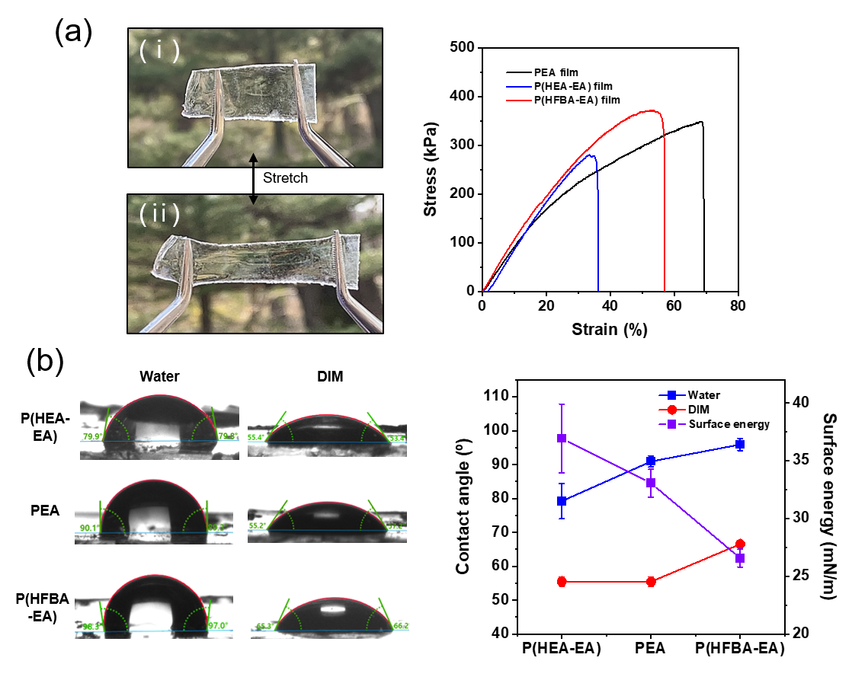

Figure 2. (a) Photographs of stretched and released transparent acrylate film (left), and their strain-stress curves (right).

Table 1. Detailed mechanical properties of crosslinked-polyacrylate film

|  |  |  |  |  |
| --- | --- | --- | --- | --- |
|  | Elongation at break (%) | Maximum stress (kPa) | Young ‘s modulus (kPa) | Toughness (kPa) |
| P(HEA-EA) film | 36.2 | 281.0 | 1004.5 | 56.4 |
| PEA film | 68.9 | 347.8 | 928.7 | 152.2 |
| P(HFBA-EA) film | 56.9 | 371.7 | 1079.6 | 135.1 |

우리는 앞서 만들었던 젖음성 변환 가능 소재를 활용도가 높은 다공성 물질로 제작하고자 하였습니다. Figure 3a에서 볼 수 있듯이, 우리는 친환경 방법인 소금 틀을 사용하여 다공성 구조를 간편하게 제작했습니다. 먼저 제작된 소금 틀에 acrylate 기반의 용액을 침투시켜 경화합니다. 그 후 내부에 존재하는 소금 틀을 물을 활용하여 제거하면 쉽고 non-harmful process로 스펀지를 제작할 수 있습니다. 우리의 다공성 물질은 소금 틀을 사용하기 때문에, 단순히 소금의 입자 크기를 조절하는 것 만으로도 다공성 물질의 기공 크기를 조절할 수 있습니다(Figure 3b and Figure S4). 예를 들어, 우리의 실험에서는 소금의 입자 크기를 볼-밀을 통해 조절하였으며 10분, 30분, 1시간 그리고 3시간씩 볼-밀을 진행하였습니다. 볼-밀 수행 시간이 증가함에 따라 소금 입자의 크기는 감소했으며, 이에 따른 다공성 물질의 기공 크기 또한 감소하는 것을 알 수 있었습니다. 다공성 물질의 기공 크기에 따라 bulk density 또한 달라졌는데, 30분 진행 샘플에서 밀도가 가장 낮았으며, 1시간과 3시간 샘플에서 밀도가 비교적 높았습니다. 30분 샘플의 경우 247~83 μm를 아우르는 넓은 범위의 기공 분포를 지니기 때문에 다른 샘플들에 비해 기공의 밀도가 낮아지게 되었습니다. 이와 반대로, 1시간과 3시간 샘플은 기공 크기가 각각 23, 16 μm로 매우 작고 좁은 범위를 가지기 때문에 상대적으로 높은 밀도를 지니게 됩니다. Figure 3c에서 볼 수 있듯이, 소재를 다공성 물질로 제작했을 때에도 좋은 유연성과 신축성을 지니는데, 이는 오른쪽의 strain-stress curves에서도 확인할 수 있습니다 (구체적 내용은 Table 2). 다공성 구조 형태에서 필름 형태와 다른 점은, elongation at break가 크게 증가하였고 maximum stress와 영 모듈러스, toughness가 크게 감소하였다는 점입니다. 우리가 추측하기에, 벌크한 필름 형태에서 벗어나 골격을 형성하는 다공성 구조는 변형이 더욱 자유롭고 늘어나기에 용이합니다. 따라서 단순 필름 형태보다 다공성 구조를 형성하는 것이 소재의 활용을 더욱 높여줄 수 있다는 결론에 도달했습니다. Figure 3d에서는 다공성 구조로 형성된 세가지 스펀지의 물/DIM 접촉각을 측정한 값입니다. HFBA가 도입된 소수성 스펀지의 경우 140도에 가까운 물 접촉각을 보였으며, 이는 pristine PEA에 비해 증가된 값이었습니다. HEA가 더해진 친수성 스펀지는 물을 흡수하여 접촉각 측정이 불가했습니다. 이는 pristine sponge에 비해 확연히 증가한 표면에너지를 증명하는 결과입니다. 세가지 샘플 모두 DIM을 흡수하였기 때문에 DIM 접촉각은 측정이 불가능 했습니다.

We aimed to fabricate a highly versatile porous material using the previously developed wetting properties controllable materials. As seen in Figure 3a, we employed an eco-friendly salt templating method to easily create a porous structure. First, we infiltrated an acrylate-based solution into the prepared salt template and cured it. Then, by removing the internal salt template using water, we could produce a sponge through a simple and non-harmful process. Since our porous material uses a salt template, adjusting the particle size of the salt particles allows us to control the pore size of the porous material (Figure 3b and Figure S4). For instance, in our experiment, we adjusted the particle size of the salt using a ball mill, performing ball milling for 10 minutes, 30 minutes, 1 hour, and 3 hours. As the ball milling time increased, the size of the salt particles decreased, and the pore size of the porous material also decreased. The bulk density of the porous material varied depending on the pore size. The 30-minute sample having the lowest density, and the 1-hour and 3-hour samples having relatively higher densities. The 30-minute sample had a wide pore size distribution ranging from 247 to 83 μm, resulting in lower pore density compared to other samples. In contrast, the 1-hour and 3-hour samples had very small and narrow pore sizes of 23 μm and 16 μm, respectively, resulting in relatively higher densities. As seen in Figure 3c, the material exhibited good flexibility and elasticity even when fabricated into a porous structure, which is also confirmed by the strain-stress curves on the right (specific details in Table 2). The key difference between the porous structure and the film form is that the elongation at break significantly increased, while the maximum stress, Young's modulus, and toughness significantly decreased. We speculate that the porous structure, forming a skeleton and deviating from the bulk film form, allows for more freedom in deformation and ease of elongation. Therefore, we concluded that forming a porous structure could enhance the material's applicability compared to a bulk film form. Figure 3d shows the water/DIM contact angles measured for the three sponges formed into porous structures. The hydrophobic sponge with HFBA introduced exhibited a water contact angle close to 140 degrees, which was an increased value compared to pristine PEA. In contrast, hydrophilic sponge with HEA absorbed water, therefore contact angle measurement was impossible. This result demonstrates a significantly increased surface energy compared to the pristine sponge. All three samples absorbed DIM, making DIM contact angle measurements impossible.

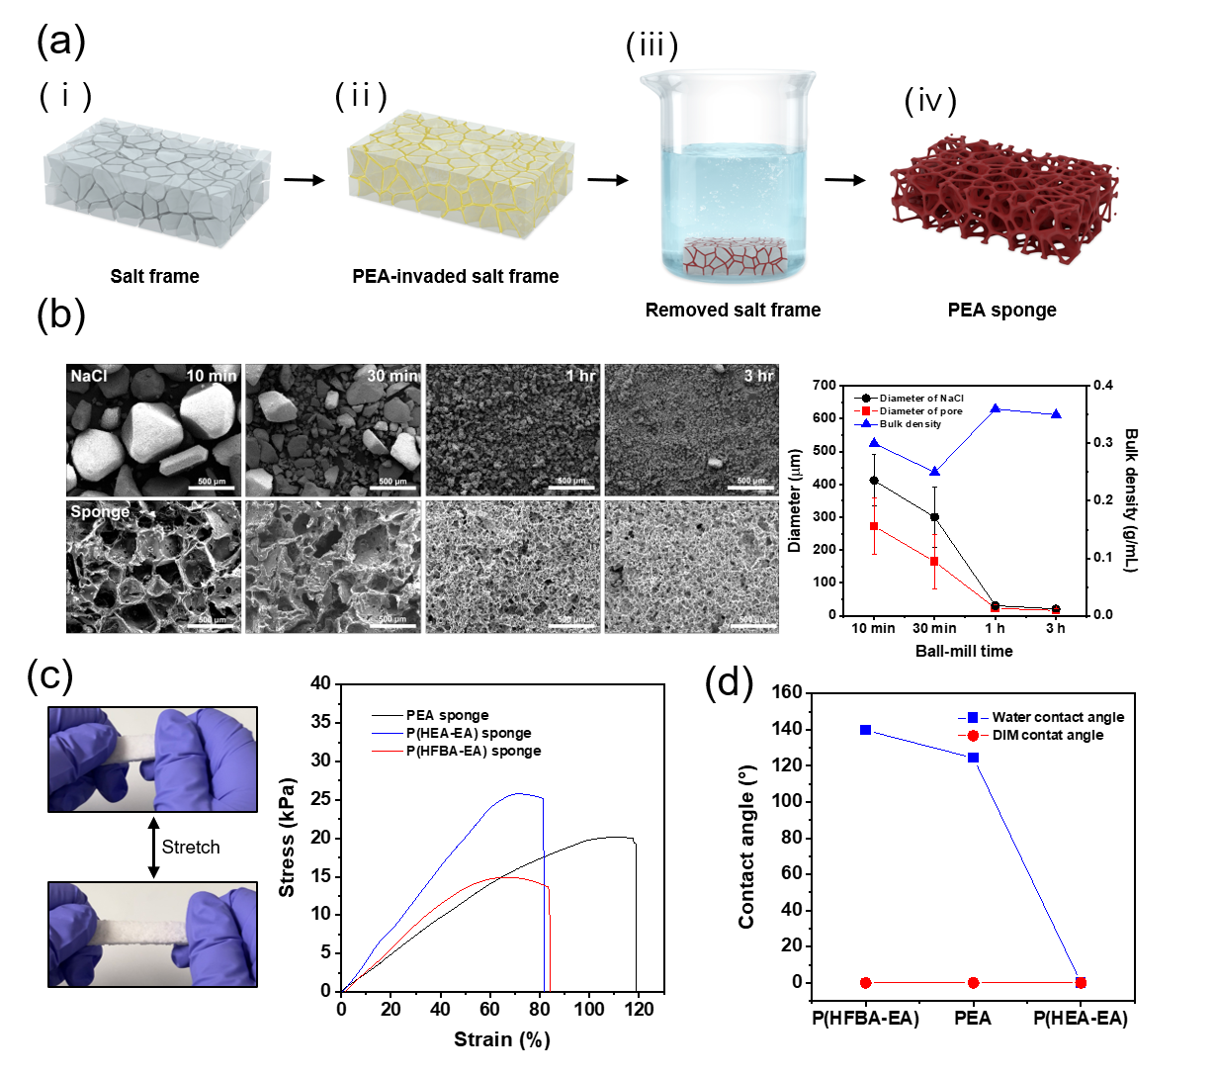

Figure 3. (a) Graphical summary of comfort formation of crosslinked-polyacyrlate. (b) SEM images (left) according to the ball-milling time of NaCl particles. Graph of NaCl, pores diameter and bulk density according to the ball-milling time. (c) Photographs of stretched and released sponge (left) and their strain-stress curves (right). (d) Water and DIM contact angle of sponges.

Table 2. Detailed mechanical properties of crosslinked-polyacrylate porous sponge

|  |  |  |  |  |
| --- | --- | --- | --- | --- |
|  | Elongation at break (%) | Maximum stress (kPa) | Young ‘s modulus (kPa) | Toughness (kPa) |
| P(HEA-EA) sponge | 81.5 | 25.8 | 44.329 | 12.7 |
| PEA sponge | 118.8 | 20.1 | 22.553 | 14.9 |
| P(HFBA-EA) sponge | 83.9 | 14.9 | 30.318 | 8.4 |

우리는 앞서 만들어진 다공성 구조 형태의 스펀지를 젖음 특성에 걸맞게 두가지 방향으로 간단한 프로토 타입을 제작하였습니다. Figure 4a에서 볼 수 있듯이, 낮은 표면에너지의 P(HFBA-EA) 스펀지는 물/기름 분리 분야에 응용하였습니다. 본 소재는 물은 밀어내고, 유기용매와 기름은 흡수하기 때문에 물과 기름의 혼합물에서 기름을 흡수하는 물/기름 분리 소재로 활용할 수 있었습니다. 뿐만 아니라 기름이 흡수된 스펀지에 압력을 가함으로써 기름을 제거하여 재사용도 가능했습니다 (Supporting video). Figure 4b에서 볼 수 있듯이, P(HFBA-EA) sponge는 20 cycle 가량 90% 이상의 분리 효율을 보였으며(i), 300%에 가까운 흡수 용량을 안정적으로 보여주었습니다(ii). 뿐만 아니라, 다양한 유기 용매 및 오일에 대해서도 높은 흡수 용량을 보이는 것을 확인했습니다. 이러한 결과를 통해 표면에너지가 감소된 P(HFBA-EA) sponge는 물/기름 분리 기능성 물질로서 사용될 수 있음을 알 수 있었습니다. Figure 4c에서는 높은 표면에너지를 갖는 P(HEA-EA) sponge에 액체금속을 흡수시킴으로써 유연하고 탄성력 있는 전도성 물질로 활용하였음을 나타냅니다. Figure 4cⅰ에서 볼 수 있듯이 LED에 불이 들어오는 것을 확인함으로써 전기가 충분히 흐르는 것을 알 수 있었습니다. 또한 figure 4c ⅱ에서는 이를 늘렸을 때에도 불이 들어오며 충분한 전도성을 띠는 것을 알 수 있었습니다. 액체금속을 넣지 않은 P(HEA-EA) sponge와, 넣은 샘플 두가지의 strain-stress를 비교했을 때, 액체금속을 넣은 경우 maximum stress가 증가하는 것을 알 수 있었습니다. 이는 스펀지의 골격 사이로 침투한 액체 금속으로 인해 인장 시에 가해지는 힘이 더욱 증가하는 것으로 보입니다. 이러한 결과는 액체금속이 흡수된 스펀지의 단면 SEM image와 이에 따른 EDS image를 보았을 때 더욱 분명하게 알 수 있었습니다. 단면을 관찰했을 때 골격 사이에 존재하는 액체 금속이 명확하게 드러났으며, EDS image에서도 액체금속의 구성원소인 갈륨과 인듐을 각각 녹색, 푸른색 점들로 확인할 수 있었습니다. 이러한 결과를 미루었을 때 스펀지의 증가된 표면에너지로 인해 액체금속이 흡수될 수 있었으며, 전도성 물질로의 활용 가능성을 알게 되었습니다.

We have developed two simple prototypes with the controlled wetting properties, applying previously created porous structure sponge. As shown in Figure 4a, the P(HFBA-EA) sponge with low surface energy was applied in the field of water/oil separation. This material repels water while absorbing organic solvents and oils, making it useful for absorbing oil from a water/oil mixture as a water/oil separation material. In addition, the sponge was reusable by removing absorbed oil using pressure (Supporting video). As illustrated in Figure 4b, the P(HFBA-EA) sponge demonstrated over 90% separation efficiency for approximately 20 cycles (Figure 4bⅰ) and stably exhibited an absorption capacity close to 300% (Figure 4bⅱ). Additionally, it was confirmed to have a high absorption capacity for various organic solvents and oils. These results indicate that the P(HFBA-EA) sponge, with reduced surface energy, can be used as a functional material for water/oil separation. In addition, figure 4c shows the use of the P(HEA-EA) sponge with high surface energy by absorbing liquid metal to create a flexible and elastic conductive material. As seen in Figures 4cⅰ and 4cⅱ, the LED lights up, indicating sufficient electrical conductivity, and the light remains on even when stretched, demonstrating adequate conductivity. When comparing the strain-stress of the P(HEA-EA) sponge without liquid metal to the sample with liquid metal, it was found that the maximum stress increased when liquid metal was added. It was because of the increased force applied during elongation, caused by the liquid metal infiltrating the sponge's framework. These results are clearly revealed by the cross-sectional SEM image and the corresponding EDS image of the sponge absorbed liquid metal (detailed information in Figure S6). The cross-sectional observation clearly shows the presence of liquid metal between the framework, and the EDS image confirms the elements of the liquid metal, gallium and indium, as green and blue dots, respectively. From these results, it can be inferred that the increased surface energy of the sponge allowed for the absorption of liquid metal, demonstrating its potential as a conductive material.

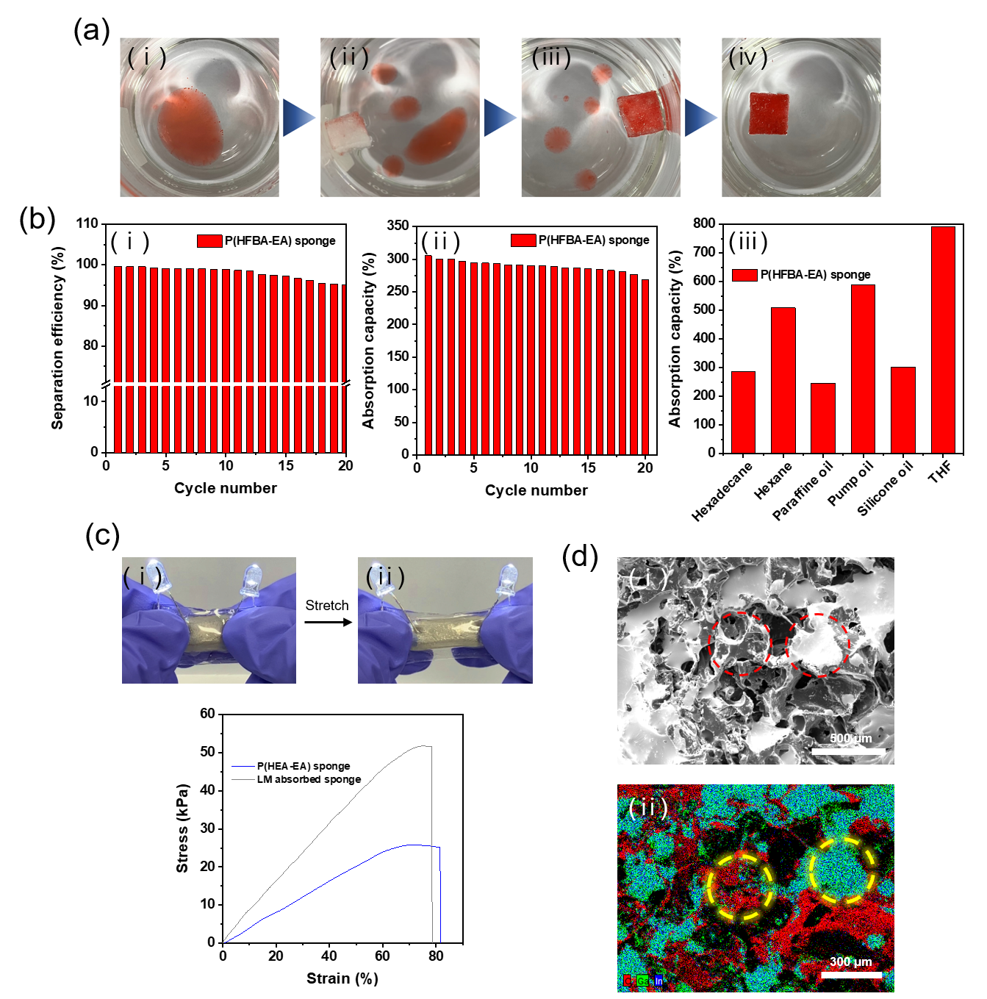

Figure 4. (a) Application of oil/water separation using P(HFBA-EA) sponge with low surface tension. (b) Application of P(HEA-EA) sponge to liquid metal containing hydrophilic sponge.

**Experimental Section**

**Chemicals**  
Ethyl acrylate (EA), poly(ethylene glycol)dimethacrylate (PEGDMA) (Mn=550), 2-hydroxyethyl acrylate (HEA), 2,2,3,4,4,4-hexafluorobutylacrylate (HFBA), gallium-indium eutectic (99.9%) and SYLGARD 184 were purchased from Sigma-Aldrich. Azobisisobutyronitrile (AIBN), sodium chloride, ethyl alcohol, tetrahydrofuran (THF) were purchased from DUKSAN. And diiodomethane, hexadecane, hexane, paraffin oil, pump oil, silicon oil were purchased from Sigma-Aldrich. All chemicals were used as received.

**Preparation of sacrificial salt frame**  
NaCl microparticles were ground in a ball-mill with stainless balls for 10 minutes, 30 minutes, 1 hour, and 3 hours to control the size of NaCl particle. After ball milling, the sacrificial salt frame was prepared as follows. Initially, a slurry of NaCl was fabricated by mixing well the ground NaCl (10g) with deionized (DI) water (2g). The resulting high viscosity mixture was poured into a Teflon plate and dried in a vacuum oven at 80 ℃ for 48 h. After drying, the sacrificial NaCl frame was removed from the Teflon plate.

**Preparation of crosslinked-PEA porous sponge**  
Initially, EA (monomer), PEGDMA (crosslinker), and AIBN (thermal initiator) were mixed in a weight ratio of 20:1.5:1.5 under magnetic stirring. After mixing for 1 h, the prepared monomer solution was poured onto a Teflon plate bearing the sacrificial NaCl plate, and cured in a vacuum oven at 67 ℃ for 24 h. Subsequently, the composite generated from the crosslinked PEA and the salt frame was obtained. The salt frame was removed by placing the composite in a beaker of water, sonicating for 12 h, and drying in a vacuum oven at 60 ℃ for 48 h.

**Preparation of wettability-controlled porous sponge**  
To obtain the wettability-controlled porous sponge, a process similar to that used to prepare the crosslinked PEA porous structure was employed. To generate the hydrophilic porous structure, EA and HEA were used as the monomers. More specifically, EA, HEA, PEGDMA, and AIBN were mixed in a weight ratio of 14:6:1.5:1.5. To prepare the hydrophobic porous structure, EA and HFBA were used as monomers. Thus, EA, HFBA, PEGDMA, and AIBN were mixed in a weight ratio of 14:6:1.5:1.5. All subsequent steps were as those described for the crosslinked PEA porous.

**Characterization**  
Fourier transformed infrared (FT-IR) spectra was recorded by using Nicolet 5700 (Nicolet). Differential scanning calorimetry (DSC) and thermogravimetric analysis (TGA) were performed using DSC Q1000 and Q100 instruments along with TGA Q5000 and Q500 instruments, respectively; these were manufactured by TA Instruments. To observe the NaCl particle and the porous structure, scanning electron microscope (SEM) was performed using a Tescan, Vega2 microscope at a high voltage of 20kV. Energy-dispersive X-ray spectroscopy (EDS) was performed using a Bruker, Detector 410. A universal testing machine (UTM) was used to observe mechanical behaviors of the porous sponges in combination with MultiTest-2.5i and Emperor TM Force software. Mercury porosimeter was conducted using a Micromeritics, AutoPore Ⅳ 9500 to calculate the bulk density of porous materials. X-ray photoelectron spectroscopy (XPS) was carried out using a Nexsa G2 instrument (Thermo Scientific). All contact angle and surface tension measurements were performed using a Kruss drop-shape analyzer (DSA100).

**Conclusion**

젖음 특성 조절이 가능한 아크릴레이트 기반의 소재는 유연하고 신축성이 좋았으며 젖음 특성 또한 확연하게 조절되었습니다. 우리가 사용한 가교된 아크릴레이트 고분자는 화학적뿐만 아니라 물리적 가교를 통해 탄성력을 지니고 있습니다. 또한 우리는 표면에너지를 높이고, 낮추기 위해 각각 -OH를 갖는 HEA와 fluoroalkyl을 갖는 HFBA를 공중합하였습니다. 실제로 물/DIM 접촉각과 이를 기반으로 계산된 표면 에너지를 확인하였을 때 젖음 특성이 성공적으로 변환되었음을 확인하였습니다. 뿐만 아니라, 우리는 해당 소재의 활용성을 증대시키기 위해 다공성 구조로 가공하고자 하였습니다. 본 연구에서는 친환경적인 소금 틀을 활용하여 다공성 구조를 제작하였으며, 소금의 입자 크기를 조절함을 통해 다공성 구조의 기공 크기와 밀도를 조절하였습니다. 다공성 구조로 가공했을 때에도 조절된 젖음 특성은 여전히 남아있었으며, 이는 소재 자체의 젖음 특성을 조절하였기 때문입니다. 게다가, 우리는 젖음 특성이 조절된 다공성 물질을 두가지의 프로토 타입의 어플리케이션으로 활용한 바가 있습니다. 낮은 표면에너지를 갖도록 조절된 P(HFBA-EA) sponge는 물-기름 혼합물에서 기름을 담지하는 흡수체로 사용되었습니다. 본 소재는 20 cycle 가까이 90% 이상의 효율을 보이는 좋은 결과를 보였습니다. 반면에, 낮은 표면에너지를 갖도록 조절된 P(HEA-EA) sponge는 마찬가지로 높은 표면에너지를 갖는 전도성 액체금속의 담지체로 사용되었습니다. 액체금속은 해당 소재의 내부까지 침투되었으며 전기가 흐르는 유연하고 탄성력 있는 전기전도성 물질로 사용되었습니다. 이러한 결과를 통해, 젖음 특성이 조절된 두가지의 스펀지는 각각 오일 및 액체금속의 담지체 역할을 충실히 수행하였음을 확신하였습니다. 또한, 표면에너지가 조절된 소재를 적절히 활용한다면 이를 활용한 무궁무진한 활용성이 더욱 증대될 것으로 기대합니다.

The crosslinked-polyacrylate with adjustable wetting properties was flexible and stretchable, and its wetting properties were distinctly controllable. The crosslinked-polyacrylate possess elasticity through both chemical and physical crosslinking with their net structure. Additionally, we copolymerized HEA, which contains -OH, and HFBA, which contains fluoroalkyl, to respectively increase and decrease surface energy. Indeed, by checking the water/DIM contact angle and the surface energy calculated, we confirmed that the wetting properties were successfully changed. Furthermore, we aimed to enhance the applicability by processing it into a porous structure. In this study, we created a porous structure using an eco-friendly salt mold, adjusting the pore size and density of the porous structure by controlling the particle size of the salt. Even after processing into a porous structure, the adjusted wetting properties remained, as the wetting characteristics were controlled within the material itself. Moreover, we utilized the porous material with adjusted wetting properties in two prototype applications. The P(HFBA-EA) sponge, adjusted to have low surface energy, was used as an absorbent for retaining oil from water-oil mixtures. This material showed good results, maintaining over 90% efficiency for nearly 20 cycles. On the other hand, the P(HEA-EA) sponge, adjusted to have high surface energy, was used as a carrier for conductive liquid metal with high surface energy. The liquid metal penetrated to the skeleton of porous structure and was used as a flexible and elastic conductive material. These results confirmed that the two types of sponges with adjusted wetting properties successfully served as carriers for oil and liquid metal, respectively. We also expect that the proper utilization of materials with adjusted surface energy will further expand their limitless applicability.